

Programme Name: ________**BCS HONS**_______________________________________

Course Code: __**CSC 1403**________

Course Name: ________**Database concept**______________________________

**Assignment** / Lab Sheet / Project / Case Study No. _**6**___

Date of Submission: ______**8/4/2020**_____________

**Submitted By: Submitted To:**

Student Name**: Dipesh Tha Shrestha** Faculty Name**: Amar Subedi**

IUKL ID: **041902900028** Department**: LMS**

Semester**: Second Semester**

Intake**: September 2019**

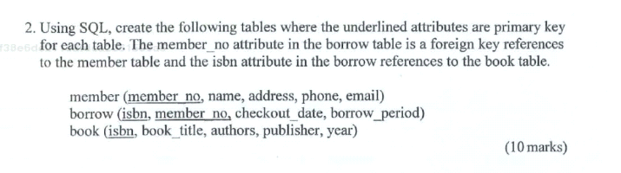

**→ Commands;**

create table member(

member_no integer(15),

name varchar(20),

address varchar(26),

phone varchar(15),

email varchar(30),

primary key (member_no) );

create table borrow(

isbn integer(15),

member_no integer(15),

checkout_date varchar(20),

borrow_period varchar(20),

primary key (isbn),

foreign key (member_no) references member(member_no) );

create table book(

isbn integer(15),

book_title varchar(26),

authors varchar(26),

publisher varchar(26),

year integer(5),

foreign key (isbn) references borrow(isbn) );

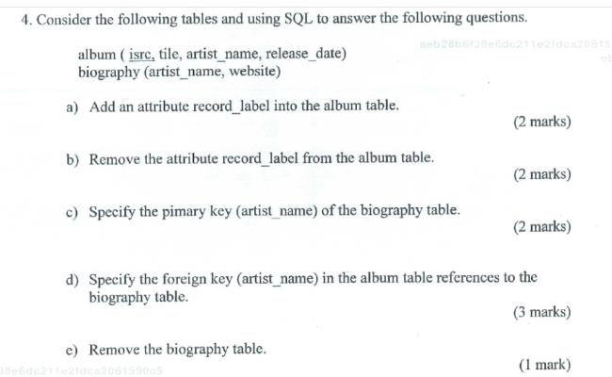

**→ Commands;**

**a)**

alter table album

add column record_label varchar(10) ;

**b)**

alter table album

drop column record_label ;

**c)**

alter table biography

add primary key(artist_name) ;

**d)**

alter table album

add foreign key(artist_name) references biography(artist_name) ;

**e)**

drop table biography;

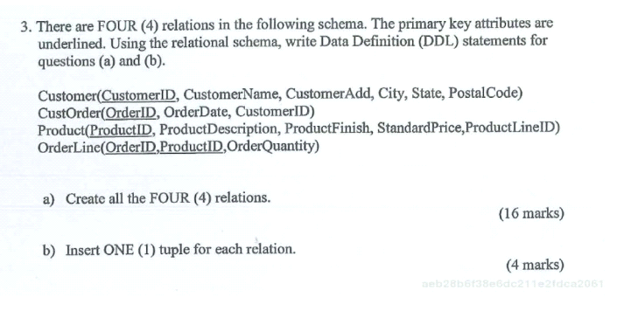

**→ Commands;**

**a)**

create table Customer (

CustomerID integer(15),

CustomerName varchar(20),

CustomerAdd varchar(26),

City varchar(20),

State varchar(20),

PostalCode varchar(15),

primary key (CustomerID) );

create table CustOrder(

OrderID integer(15),

OrderDate varchar(20),

CustomerID integer(15),

primary key (OrderID),

foreign key(CustomerID) references Customer(CustomerID) );

create table Product(

ProductID integer(15),

ProductDescription varchar(20),

ProductFinish varchar(20),

StandardPrice integer(15),

ProductLineID integer(15),

primary key (ProductID) );

create table OrderLine(

OrderID integer(15),

ProductID integer(15),

OrderQuantity integer(15),

foreign key (OrderID) references CustOrder(OrderID),

foreign key(ProductID) references Product(ProductID) );

**b)**

insert into Customer(CustomerID, CustomerName, CustomerAdd, City, State, PostalCode)

values( 002, “L Lawliet”, “Steet 4, 226”, “Tokyo”,“State 3”,“44388” );

insert into CustOrder(OrderID, OrderDate, CustomerID)

values( 1102, “03-07-2020”,002);

insert into Product(ProductID, ProductDescription, ProductFinish, StandardPrice, ProductLineID )

values( 5666, “Death Note”, “Finished”, 50,000, 7276 );

insert into OrderLine(OrderID, ProductID, OrderQuantity )

values(1102, 5666, 1);

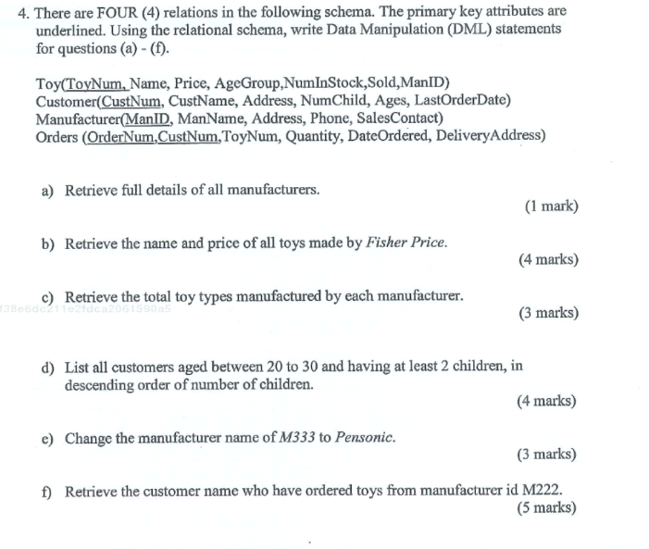

**→ Commands;**

**a)**

select * from Manufacturer;

**b)**

select t.Name, t.Price

from Toy as t inner join Manufacturer as m on t.ManID= m.ManID

where m.ManName= “Fisher Price”;

**c)**

select m.ManName, count(t.ToyNum) as Total_toy_types

from Toy as t inner join Manufacturer as m on t.ManID= m.ManID ;

**d)**

select * from Customer where

Ages > 20 and Ages <30

and NumChild >= 2

order by Numchild desc;

**e)**

update Manufacturer set ManName= “Pensonic” where ManID= “M333”;

**f)**

select c.CustName from Customer as c

inner join Orders as o on c.CustNum = o.CustNum

inner join Toy as t on o.ToyNum = t.ToyNum

inner join Manufacturer as m on t.ManID = m.ManID

where m.ManID=”M222”;

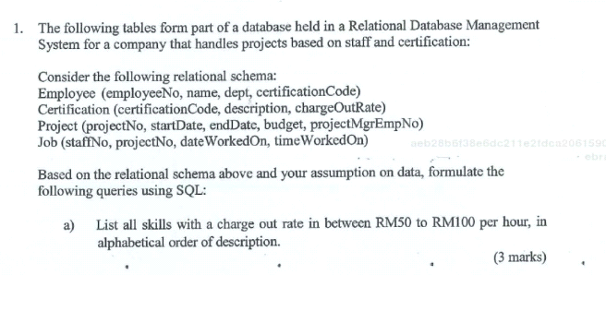

**→ Commands;**

**a)**

select * from Certification

where chargeOutRate>50 and chargeOutRate<100

order by description asc;



**→ Commands;**

**b)**

select * from Employee as e

inner join Certification as c on e.certificationCode= c.certificationCode

where c.description= “PMP”

and e.dept = “Software Construction Projects”;

**c)**

select e.name, p.projectNo, j.dateWorkedOn, j.timeWorkedOn

from Employee as e

inner join Project as p on e.projectNo = p.projectNo

inner join Job as j on p.projectNo= j.projectNo

where p.startDate= “Dec 2015”

order by e.name , p.projectNo, p.startDate ;

**d)**

select count(emloyeeNo) from Employees where certificationCode = “CPRE”;

**e)**

select * from Project where projectMgrEmpNo >= 18;

**f)**

select Avg(chargeOutRate) from Certification;

**g)**

select e.name

from Employee as e inner join Certification as c on e.certificationCode = c.certificationCode

where c.chargeOutRate > Avg(c.chargeOutRate) ;







**→ Commands;**

**a)**

select * from Skill

where chargeOutRate > “RM150”

order by description asc;

**b)**

select s.name from Staff as s

inner join Skill as sk on s.skillCode = sk.skillCode

where sk.description = “Requirements Engineer” and s.dept = “IT Projects” ;

**c)**

select s.name, b.dateWorkedOn, b.timeWorkedOn, p.projectNo

form Staff as s

inner join Booking as b on s.staffNo = b. staffNo

inner join Project as p on b.projectNo = p.projectNo

where p.startDate= “August 2015”

order by s.name, p.projectNo, p.startDate ;

**d)**

select count(s.staffNo) from Staff as s

inner join Skill as sk on s.skillCode= sk.skillCode

where description = “PHP Programmer” ;

**e)**

select * from Project where projectManagerStaffNo >= 7;

**f)**

select Avg(chargeOutRate) from Skill;

**g)**

select s.name from Staff as s

inner join Skill as sk on s.skillCode = sk.skillCode

where sk.chargeOutRate > Avg(sk.chargeOutRate) ;

**\*\*\*\* THE END \*\*\*\***